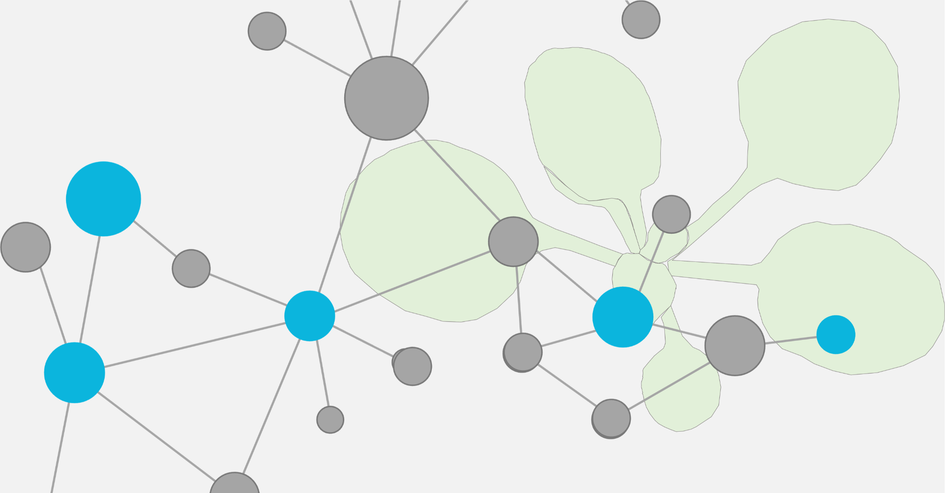

DataPLANT Community Call 2026 Proposal Submission Form

The DataPLANT Community Call is structured around two main pillars: DataSteward Support and a Project Call. DataSteward Support aims to accelerate data stewardship capacities by offering a structured Onboarding Kit for new stewards, Direct DataSteward Support (dedicated assistance for project-specific tasks), and Personnel funding for facilities or consortia to locally employ stewards, ultimately enhancing data management expertise and FAIR-compliant workflows across the plant science community. The Project Call supports practical, community-driven initiatives that develop tools, workflows, or resources within the DataPLANT ecosystem to advance FAIR data practices in plant science; examples include the creation of ARC datasets, tool development, building interfaces between systems, community events (like hackathons or workshops), and creating templates and tutorials. Innovative proposals that contribute to FAIR data in plant research are highly encouraged for the Project Call.
Deadline: January 15, 2026
Earliest Funding Start: April 1, 2026 (earlier start might be considered in justified cases)
Funding Range: €10,000 – €70,000 per (running) year
For questions or submission of your funding proposal, please contact us via email: communitycall@nfdi4plants.org. Please note that for submission, a budget form needs to be filled out.

Part 1: General Project Information
Select the funding pillar for your proposal and provide the title, acronym, keywords, duration, and planned start date for your proposal.

Funding Pillar Suggestion
Please indicate which funding pillar you are applying for. If “DataSteward Support” is selected, please define the type of request.
[ ] | Project Call (PC)
[ ] | DataSteward Support (DS)
 | [ ] DataSteward Onboarding Kit
 | [ ] Direct DataSteward Support
 | [ ] Personnel funding for local DataSteward position

Proposal Title
Provide a concise and descriptive title for your project or activity.

Short Title / Acronym
Provide a short name or acronym, if applicable.

Keywords
List 3-5 keywords, separated by commas.

Requested Project Duration (months)
Enter total months (A typical duration does not exceed 1 year).

Earliest Project Start Date
Must be 01.04.2026 or later (earlier start might be considered in justified cases).

Part 2: Applicant and Team Details
Provide details for the main applicant (contact person) and list any co-applicants who will contribute to the project.

Main Applicant (Contact Person)

Full Name
Title, firstname, lastname of main applicant

Institution/Department
Full address of main applicant institution

E-Mail Address
E-mail address of main applicant

[ ] Declaration of Intent: I confirm that the submitting institution is aware of and approves this funding application.

Additional Co-Applicants

Co-Applicants
Please list all co-applicants who will contribute to the project, providing for each person: Full Name, Institution, and E-Mail address. Please use a new line for each co-applicant.

[ ] Declaration of Intent: I confirm that all above listed co-applicants are aware of and approve this funding application.

Eligibility Confirmation

Affiliation with the Plant Community
Please explain briefly how you are a member of, or affiliated with, the plant community and how your proposal is relevant to plant research. (Max. 250 words)

Part 3: Project Details and Scientific Background
Describe your project's motivation, target group, and specific objectives.

Project Abstract / Executive Summary
Summarize the entire proposal (problem, solution, expected outcome). (Max. 250 words)

Background and Need
Describe the status quo, the challenge, and the necessity for the planned activity. (Max. 250 words)

Target Group / Community Relevance
Describe which parts of the plant science community the project addresses. (Max. 250 words)

Sustainability
How will results remain useful beyond the project duration?

Connection to DataPLANT Infrastructure
Describe how the outcome of your project will directly connect to or strengthen the existing DataPLANT infrastructure. Specifically address the use or extension of core components like the ARC (Annotated Research Context) framework, or other DataPLANT tools/services. (Max. 250 words)

Part 4: Work Plan, Milestones and Deliverables
Please provide your work plan, milestones, and deliverables using a clear, structured format.

Work Packages
Break down the work into 2–4 focused Work Packages (delete unused workplace templates).
Work Package 1
Title
List of Tasks | - Task 1  - Task 2  - Task 3
Short description of WP
Lead Institution

Work Package 2
Title
List of Tasks | - Task 1  - Task 2  - Task 3
Short description of WP
Lead Institution

Milestones
Define 3–5 specific, well-defined milestones for the whole project duration (delete unused milestone rows).
# | Milestone | Work Package | Institution | Achieved after month
1
2
3

Deliverables (Expected Outputs)
Define the expected tangible outputs (e.g., report, documented workflow, software, number of created/published ARCs - delete unused or extend needed deliverable rows).
# | Deliverable  Short Description | Work Package | Institution | Achieved after month
1 | Deliverable Title  This deliverable is about...
2 | Deliverable Title  This deliverable is about...
3 | Deliverable Title  This deliverable is about...

Part 5: Additional Information

Have you previously collaborated with DataPLANT?
Please indicate whether you have previously collaborated with or received financial or substantive support from DataPLANT. If “Yes” is selected, please provide a brief description.
[ ] | No
[ ] | Yes  Description  If applicable

Are there synergies with other NFDI consortia or projects?
Please indicate whether your proposal builds upon, complements, or collaborates with other NFDI consortia, research infrastructures, or related projects. If applicable, describe the nature of the collaboration or synergy.

Any additional comments or remarks
You may use this field to provide any further information relevant to your proposal that has not been covered above. This could include contextual details, specific needs, or clarifications for the reviewers.

Part 6: Financial Planning

Requested Total Funding (€)
Enter the total amount requested in EUR. (Must be between €10,000 and €70,000).

Strategy for Immediate Spending
Explain how an immediate start of the project and spending of funds can be ensured.
A detailed budget calculation file containing a full breakdown of requested funds per partner and cost type MUST be submitted alongside this document.

Part 7: Confirmation
By submitting this proposal, the Main Applicant confirms agreement with the following mandatory declarations:

Data Processing Consent
[ ] | I agree to the processing of my data for the purpose of application submission, evaluation, and selection.

Reviewer Consent
[ ] | I agree to the disclosure of this proposal to the persons and institutions involved in the selection process.

